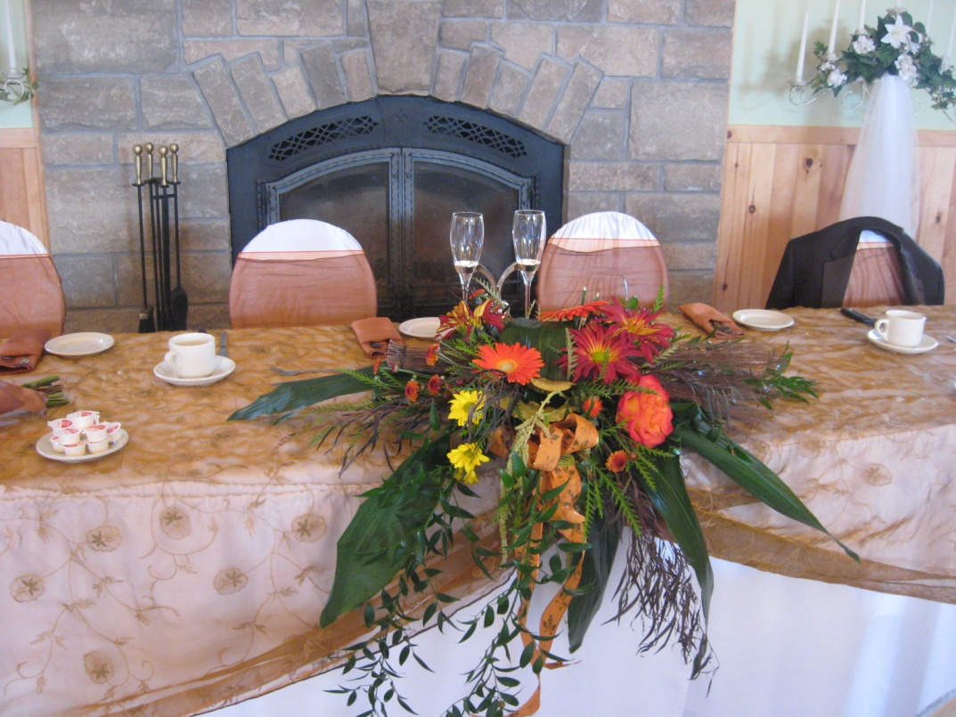**To Welcome Your Guests In Style**



**Cocktail**

* **Non-Alcoholic Punch___________$3.50 p.p.**
* **Crémant de pommes ___________$5.00 p.p.**
* **Alcoholic Punch ______________$5.00 p.p.**
* **Sangria____________________$6.00 p.p.**
* **Sparkling Wine______________$7.00 p.p.**
* **Open Bar __________________(Bar tab)**
* **Toonie Bar__________________(bar tab)**

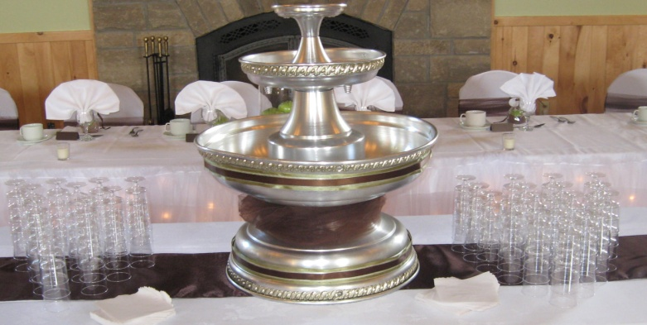

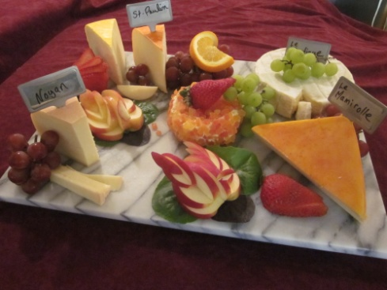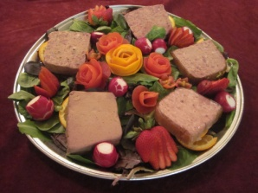

**Canapés and Platters**

**During the cocktail**

* **3 canapés per person___________________________$6.25**
* **4 canapés per person___________________________$7.25**
* **5 canapés per person___________________________$8.00**
* **Hot maple Brie (10-12 people.)___________________________ $37.50**
* **Hot bacon and cheese dip (10-12 people)___________________$38.00**
* **Vegetable and dip platter (20-25 people.)________________ __$40.00**
* **Fresh fruit platter (20-25 people)_________________________$55.00**
* **Fresh strawberry and cream platter (20-25 people)__________$55.00**
* **Chocolate covered strawberry platter (20-25 pers.)_________$60.00**
* **Cheddar cheese and brie platter (20-25 people)______________$60.00**
* **Fine cheese platter (20-25 people)_________________________$85.00**
* **Pâtés and terrine platter (20-25 people)____________________$80.00**

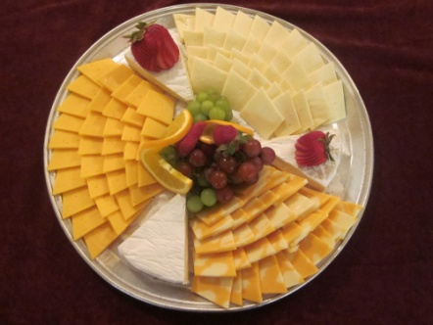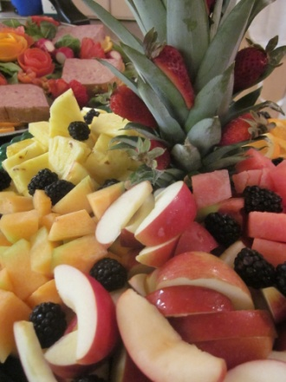

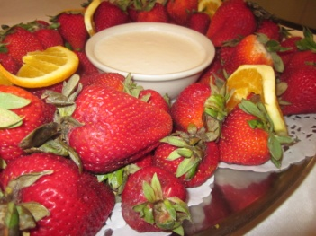

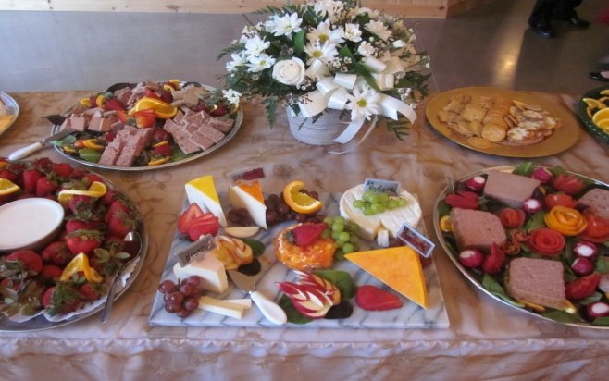

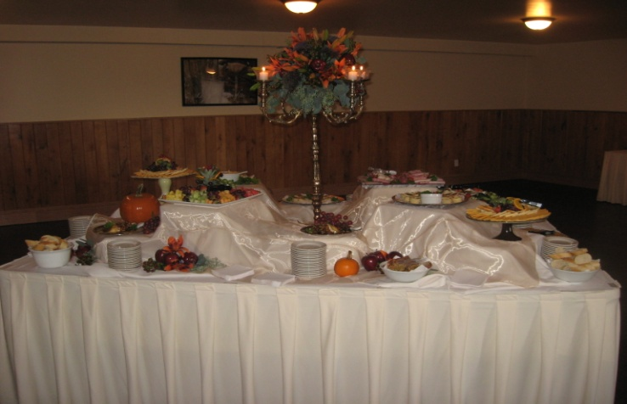

**\*\*Taxes et service en sus**

**\*\*Price subject to change without notice**

**\*\*Liquor license**

**Wine during Meal**

* **Vin d’honneur (1 glass of house wine Lab/Barefoot per person)____$6.50 p.p.**
* **House Wine : bottle 750 ml Lab snd , Bin 65**________­­ **$23.00**
* **House Wine : bottle 750 ml Vivolo Di Sasso , Barefoot _ $25.00**
* **House Wine : bottle 1 L Grand Sud Chardonnay, Merlot_$28.00**
* **House Wine : bottle 750 ml Mirassou , Fumée s blanches _$33.00**
* **Possibility of S.A.Q. Wine selection**